For More Information Contact:

Chris Kemmer, PR Consultant
CK Marketing & Communications
614-459-9369/614-596-3730
chris@ck-marketing-communications.com

or

Craig Smith, Vice President Marketing and Communications
Pressure Systems International
csmith@psitireinflation.com

News Announcement

For Immediate Release

P.S.I.’s TireView LIVE Data Portal Goes Mobile
San Antonio, TX (April 13, 2023) P.S.I. has released TireView LIVE’s mobile app for Apple/Android devices, making many of the features and benefits of the data portal available from any location so fleets can make timely decisions about their tire management.
TireView LIVE™ delivers tire analytics with customizable alerts and reports communicating to commercial fleet operators the information required to manage their tire costs for trucks and trailers, online, in real-time. Now that accessibility is completely portable with information on mobile devices.
The TireView LIVE mobile app features include:
- Tire alerts at-a-glance
- Pre-trip tire inspections and post-trip analysis
- Sort and share data to make best decisions about PM and in-transit repairs
- Convenient over-the-air (OTA) updates and sensor pairing by capturing sensor QR codes using mobile device camera
- View and drill down by region, terminal and vehicle type
- Requests for customer and tech support can be made within the app.

TireView LIVE account set up and integration requests can be accessed on the P.S.I. website. Additionally, installation, comprehensive product information and all product manuals can be viewed on line or downloaded on the resource tab.
The TireView LIVE product is an open platform API. The P.S.I. website includes a list of integration partners that can be used to consolidate tire data through a single gateway. You may also inquire about additional integrations if your partner is not listed.

About Pressure Systems International, a Clarience Technologies Company

Pressure Systems International (P.S.I.®) is the global leader in onboard tire management systems for commercial vehicles. P.S.I.’s portfolio includes automatic tire inflation systems (ATIS) for commercial trailers, tire pressure monitoring systems (TireView® TPMS) and related (TireView LIVE™) telematics products.
Website: www.psitireinflation.com

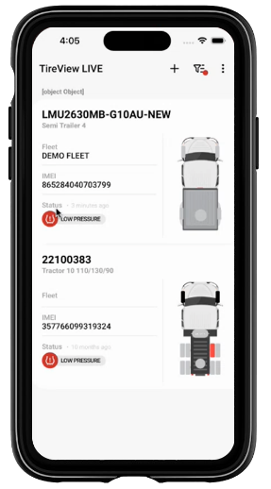
TireView LIVE iPhone App Screen

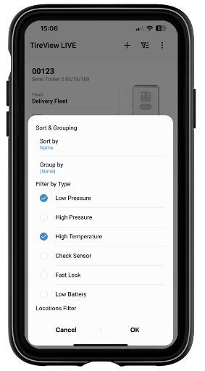
TireView LIVE iPhone App Screen – Drill Down
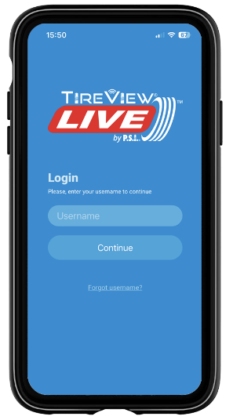
TireView LIVE iPhone App – Home Page
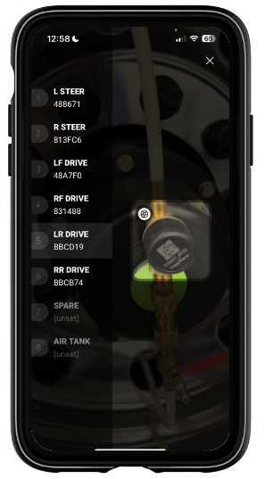
TireView LIVE – iPhone App – Sensor Coding

